**Specifications for the control Architecture of the PL_ONE (Manual mode)**

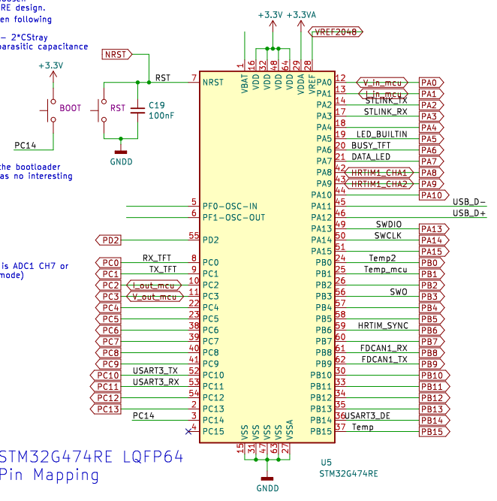

|  |  |  |  |  |  |
| --- | --- | --- | --- | --- | --- |
| Board Peripheral | MCU  Peripheral | pins | Type | Description |  |
| TFT |  |  |  |  |  |
|  |  |  |  |  |
|  |  |  |  |  |
| ADC |  |  |  |  |  |
|  |  |  |  |  |
|  |  |  |  |  |
|  |  |  |  |  |
| RS485 BUS |  |  |  |  |  |
|  |  |  |  |  |
|  |  |  |  |  |
|  |  |  |  |  |
| STLINK |  |  |  |  |  |
| CAN BUS |  |  |  |  |  |
|  |  |  |  |  |
|  |  |  |  |  |

**General informations about the system :**   
1 – Modules Boards are defined as master or slave in their code source and that feature can't be changed by the customer.

2 - The master board is the one wich is connected to the screen .

3 - all boards are connected to the CAN bus through RJ45 connection .

Output of PL_ONE Box

Master

Figure 1: Typical application

5-The General Converter Mode (GCM) and the IN_OUT parameters (voltage , current , etc…) can’t be change in real time . A startup is needed for all the board to start together with the same regulation parameters.

6- Battery in input need to be charged a little bit or PL_one can not start

**Startup sequence**

1. A switch allow voltage to go to input of feeder
2. Fedeer **power supply active (UVLO treated with NCP700 and TI)**
3. **Initial Checkup sequence** (measure of board state :

Board state :

* Temperatures boards_init < 80deg
* Vin_init < 100V
* Vout_init < 100 V
* Iin_init= < 25A
* Iout _init < 25A

Initial board status checkup (Bool Init_bd_st_ckp) return :

All ok (return 1)

If : ( TB < value , Vin < value , Vout < value , Iin < value , Iout < value)

Otherwise , Board status checkup return a fault (0) and the code execution can’t continue.

A constant supervision of these parameters need to be done to be able to stop PWM generation in case of problem .

That constant supervision will compare the parameters :

* Temperatures boards_init < 80deg
* Vin_init < 100V
* Vout_init < 100 V
* Iin_init= < 25A
* Iout _init < 25A

With some references.

3 - **Status Led**

The status LED is directly driven by a PWM signal from the PIN Data Led (PA7) of MCU.

That PWM signal determine the color of the LED

And the color of the LED is green if Bool Bd_st_ckp =1 and red if Bool Bd_st_ckp=0

(Green if no default and red if default )

Default triggered depending of the values of IN_OUT_parameters reflecting the board state.

4-**TFT Screen access**

Once the status LED pass to green the user can access the TFT screen

Check the possibility to block access to the TFT screen with the busy TFT pin (PA6) of MCU.

On the TFT screen, the user can :

4-1- **User define the General System Mode in automatic or manual**

The automatic system mode is defined in another document

**Automatic mode brief description :**

The converter go get infos from the battery and from the inverter and use theses infos to decide of the regulation mode and of the regulation parameters.

**Manual mode brief description :**

The user enter the infos for the regulation mode and of the regulation parameters.

4-2- **User define the Regulation Mode of the Converter COVMode or BatChMode**

Here the user choose between a

Constant_Output_Voltage_Mode (COVMode) or a battery_charging_mode(BatChMode)

4-2-1- **COVMode**

Parameters to be entered by the user :

OUTPUT_VOLTAGE : Value to regulate in converter output

OUTPUT_VOLTAGE_MIN_MAX : (min,max) voltage output for battery protection

INPUT_VOLTAGE_MIN_MAX : (min,max) voltage input for battery protection

The parameters OUTPUT_VOLTAGE_MIN_MAX and INPUT_VOLTAGE_MIN_MAX can be used to update the references of the supervision table.

In this mode the max input or output current is the one specified by the product and the product will enter in fault mode if the current limit is triggered for a define period.

**4-2-2- BatChMode**

Parameters to be entered by the user :

OUTPUT_CURRENT : Current value to regulate in converter output

OUTPUT_VOLTAGE_MIN_MAX : (min,max) voltage output for battery protection

INPUT_VOLTAGE_MIN_MAX : (min,max) voltage input for battery protection

In this mode the max input or output current is the one specified by the product and the product will enter in fault mode if the current limit is triggered for a define period.

For both modes the max charge and discharge battery current is also entered by the user.

Theses two parameters are used as fault mode reference only if they are inf to the max current of the PL_ONE.

Otherwise the max current of the PL_ONE is used.